

UNIVERSITI TEKNOLOGI MALAYSIA

HUMAN COMPUTER INTERACTION

ASSIGNMENT 1:
PERSUASIVE TECHNOLOGY OF THE WAZE APP
(SDG 9: INDUSTRY,INNOVATION AND INFRASTRUCTURE)

DR NUR ZURAIFAH SYAZRAH OTHMAN
NO | NAME | MATRIC NO
1. | MUHAMMAD MUKHRITZ AL IMAN BIN MOHD RAFFI | A23CS0250
2. | IMAN ABADI BIN MOHD NIZWAN | A23CS0084
3. | MUHAMMAD NAIM BIN ABDULLAH | A23CS0134

WAZE APP (SDG 9: INDUSTRY, INNOVATION AND INFRASTRUCTURE)
- Purpose

Waze is considered an innovation among other navigation apps that uses input from its users to help drivers avoid traffic delays and accidents. By sharing real-time traffic data, users help each other navigate the roads more efficiently. The collaborative community on Waze benefits everyone by providing valuable information and improving the driving experience for all.

- Target Behaviors & Fogg Behavior Model (FBM)
The FBM identifies three key factors that influence behavior change: motivation, ability, and trigger. Waze strategically incorporates these factors into its design to encourage users to participate using two key features:

- Reporting Traffic Incidents:
Trigger
Waze has both auditory notifications (optional voice prompts) and visual cues (pop-up icons) to inform users about the option to report a traffic incident while they are on the road. It uses spark as a trigger which is used when the user lacks motivation to perform a target behavior. It uses icons that highlight such as an icon that signifies a crash accident.

Motivation
Waze uses hope/fear as its motivator. It can be applied when the user has the fear of themselves or others having a bad experience while in traffic. For example, reporting potholes is one of the ways to prevent possible accidents when someone drives in the affected area. The reports are made in hopes that other users will avoid using that road. This will foster a sense of community and shared responsibility between users.

Ability
Waze also takes the advantage of human nature of wanting to use minimal effort and time by using physical effort and time as its elements of simplicity. Reporting an incident is as easy as tapping the pop-up icon and selecting the appropriate category (e.g. accident and potholes). The app's user interface is designed to be user-friendly while driving, minimizing distractions.

- Following Waze-Suggested Alternate Routes:

Trigger
For this feature, Waze uses signal as a trigger. This is suitable for this feature as users have high ability and motivation to do the target behavior. They have the ability to drive and the motivation to not be stuck in traffic. The app applies this by notifying users about heavy traffic and offers a different route. It displays the time taken of each route and highlights the suggested route that has the least issues reported. This will help the user make a plan on which route that they want to use.

Motivation
As mentioned from the last feature, Waze uses hope/fear as its motivator. The promise of a faster journey and avoiding traffic are the main motivators for users, also taking advantage of the fundamental human desire for efficiency and time-saving solutions. The irritation and wasted time of sitting in heavy traffic only serves to increase this motivation. Waze takes advantage of this by skillfully displaying several routes along with estimations of how much time they will save. This creates a contrast that encourages users to choose the more efficient route.

Ability
Waze uses physical effort, time and brain cycles as its element of simplicity for this feature. The addition of brain cycles as another element implies that users often choose something that does not require the need to think deeply. After users choose their desired destination, users simply tap the "Go" button once to confirm the suggested route. They can easily follow the app's guidance by viewing the new route and expected travel time clearly on the map.

- Video Demonstration

LINK VIDEO LETAK DEKAT

- Feature Failing to Persuade & Improvement Suggestions

While Waze excels at real-time traffic updates, the app's reliance on user-reported data can sometimes lead to inaccurate information, especially for less common incidents (e.g., road closures).

Reason:

The limited capability of Waze may be attributed to the possibly inaccurate data provided by users. The users are susceptible to wrong assumptions due lack of information. The users might just report on the traffic but neglect the reasons on why the traffic occurs.
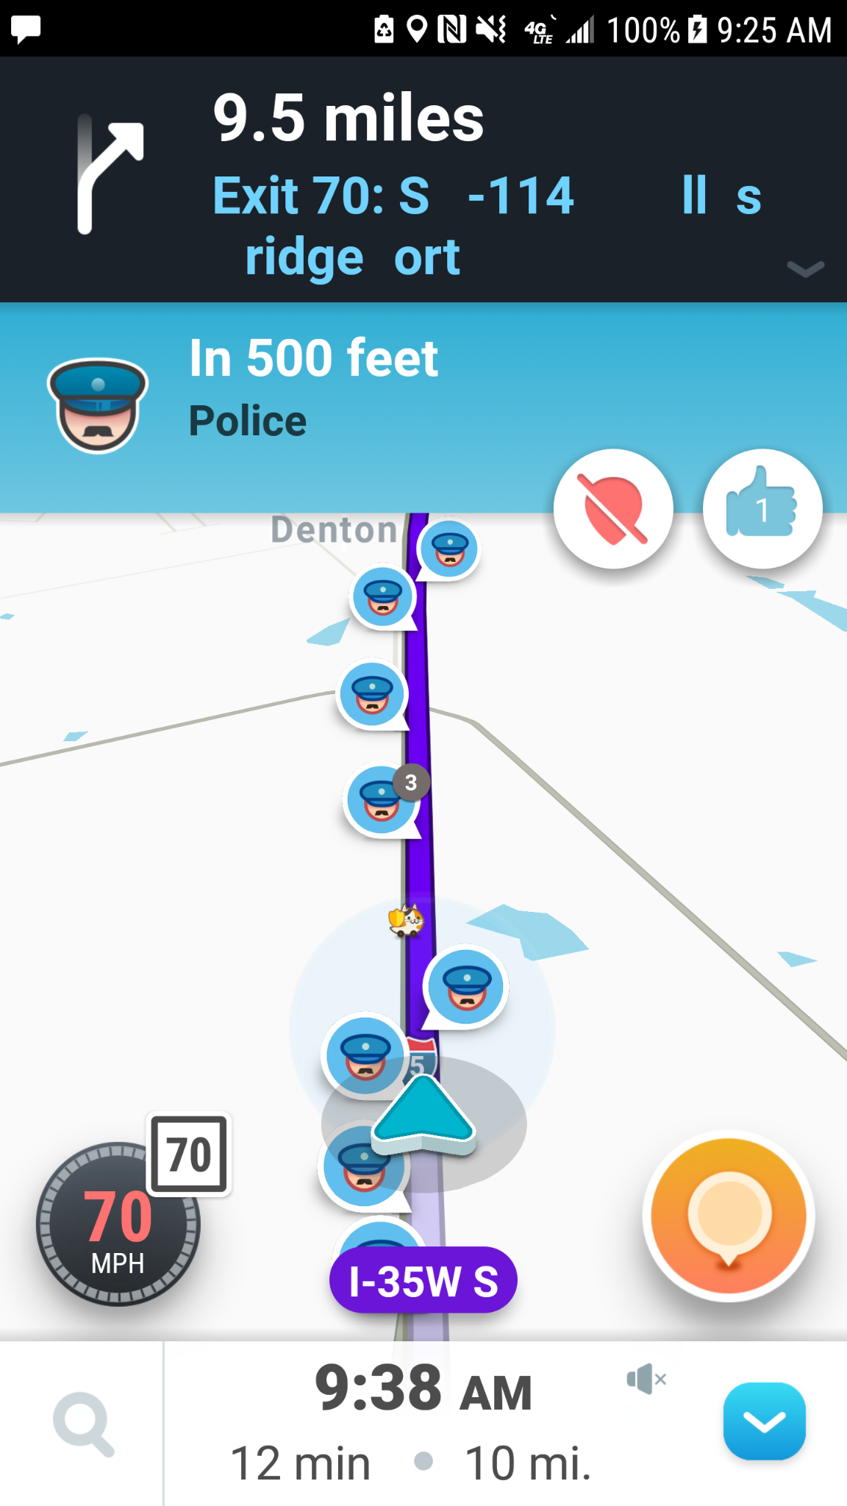

Example: Inaccurate report by multiple users, indicating an unreasonable number of police along the route.
Suggestion for Improvement:
To enhance the accuracy of Waze's traffic updates, it is recommended to connect Waze to official sources of traffic information provided by regional transportation administrations (PLUS Expressways). This will provide a more reliable source of information for specific incidents.

REFERENCE

Topic 2 Slide - Cognition and Emotional Interaction

Fogg, Brian J. "A behavior model for persuasive design." Proceedings of the 4th international Conference on Persuasive Technology. ACM, 2009.

